Acids and Bases

Properties of Substances

Acids:
- Conduct electrical current
- Turns blue litmus paper red
- Has a sour taste
  - Most metal oxides have low solubilities (low K value)

Bases:
- Conduct electricity
- Turns red litmus paper blue
- Has a soapy feel

Data Sheet
- All Metals are silvery grey unless specified by data sheet as Other Coloured Substances
- Look at top table to determine colour as a solid
  - If solid is not present in table, go to end table. If it contains an ion from bottom table, solid takes its colour
- Look at bottom table to determine colour of aqueous substance
  - Solids often take colour as aqueous ion
- Look at third table to determine colour of free halogen (not mixed)
- Look at fourth table to determine colour of aqueous halogen
- Fifth table shows colour of halogen in organic solvent

Terminology
- Acids are proton donors
- Bases are proton acceptors
- Alkali are soluble bases
- A strong acid is a substance that fully ionizes in solution and is a proton donor
- A weak acid is a substance that partially ionises in solution and is a proton donor
- A concentrated acid is a substance with a high number of acid moles per unit volume
- A diluted acid is a substance with a low number of acid moles per unit volume

Strength
- Substances can be both weak and concentrated/strong and diluted
- Strong acids are:
  - HNO₃
  - H₂SO₄
  - HCl
- Weak acids are all other proton donors
- Strong bases are:
  - Group 1 and 2 metal oxides and hydroxides
- Weak bases are all other proton acceptors

- includes:
  - NH₃ which is a base
  - H₃PO₄ which is weak acid
  - HF which is weak acid
  - HSO₄⁻ which is amphiprotic, but tends to be an acid
  - H₂PO₄⁻ ⇒ amphoteric, tends to be acidic
  - HPO₄⁻ ⇒ amphoteric, tends to be basic
  - HC₂O₄⁻ ⇒ tends to be acid
  - HCO₃⁻ ⇒ tends to be basic
- To determine strength of a substance, separate substance into ions then perform hydrolysis with acidic/basic substance

Acid-Base Reactions
$Acid+Base→Salt+water$$$Acid+Metal→Salt+H_{2 \left(g\right)}$$ $Acid+Metal Sulfite→Salt+water+SO_{2 \left(g\right)}$ $Base+NH_{4}^{+}→Salt+water+NH_{3}$ $Base+non metal oxide→Salt+water$
- Non-metal oxides are acidic (ex. SO2 or CO2), as they react with H₂O to form an acid (ex. H₂CO₃ or H₂SO₃), which ionises

Brønsted-Lowrey Theory
- Acid-base reactions are reversible
- Acids are proton donors
- Bases are proton acceptors
- **-no contrasting questions between BL and Arrhenius will come up (older questions)
- H₃O⁺⇒H⁺⇒proton

Conjugate Acid-Base Pair
$$A^{'}+B^{'}→A+B$$
- If A’ is acid, A is conjugate base
- If B’ is base, B is conjugate acid
- A’ and A are conjugate pairs $(A'|A)$
- B’ and B are conjugate pairs $(B'|B)$

Amphiprotic
- Substances that can both donate and accept protons ⇒ amphiprotic
- Substances that can react as acid or base ⇒ amphoteric
  - All amphiprotic substances are amphoteric, but all amphoteric substances are not necessarily amphiprotic
  - Amphiprotism ⇒ Amphiterism NOT Amphiprotism ⇔ Amphiterism
  - Ex. Al₂O₃ is amphoteric, but not amphiprotic ⇒ cannot donate protons
- An amphiprotic substance will act as an opposite (acid/base) to the other substance
- Polyprotic acids that have a mid-charge are amphiprotic

Solubility/Strength
- Use K to determine whether amphiprotic substance is more acidic or basic
- Carbon-based organic acids are generally weak
- Conjugate of strong substance is weak

Polyprotic
- Polyprotic substance donate multiple protons in solution
- K decreases with each donated proton:
$$K_{1}>K_{2}>K_{3}…$$
- Number of protons present provides no info about strength

Self-Ionization of Water
$$K_{w}=\left[OH^{-}\right]\left[H_{3}O^{+}\right]={10}^{-14} \\ {2H}_{2}O_{←}^{→}H_{3}O^{+}+{OH}^{-} \\ \left[H_{3}O^{+}\right]=\left[OH^{-}\right] \\ ∴{\left[H_{3}O^{+}\right]}^{2}={10}^{-14} \\ ∴\left[H_{3}O^{+}\right]={10}^{-7}$$
- Reaction is endothermic
  - Therefore, when temperature increase [products] will increase
  - Therefore, [H3O+] increases, hence, as pH=-log[H3O+], pH decreases
  - However, solution remains neutral as [H₃O⁺]=[OH⁻]

Hydrolysis
- Hydrolysis is the reaction between substance and water to produce an ion
- Model answer:
  - Hydrolysis of A’ (proton donor) produces H₃O⁺ in solution when reacting with H₂O (proton acceptor). Therefore, A’ is an acid
    - Supported by equation
- HCO₃⁻, CO₃²⁻, HPO₄²⁻, PO₄³⁻ and SO₄²⁻ an bases
- HSO₄⁻, H₂PO₄⁻ and group 13 metals are acids

Buffers
- A buffer is a solution that resists changes in pH when a small amount of acid or base is added
  - Ex. Weak acid and its conjugate base
$$CH_{3}COOH|CH_{3}COO^{-}$$
- Buffering capacity is the extent to which a buffer resists change in pH, when a small amount of acid or base is added
  - Substances that have higher buffer capacities are better buffers

Factors that affect buffering capacity include:
- Exact concentration of each solution
- Relative concentration of each solution
  - Aquimolar amounts of acid and conjugate base is required, or buffering capacity will be low
- Type of chemical used

How to explain Buffer chemistry
- Acid added
  - Always start with acid hydrolysis
$$x^{'}+H_{2}O{}_{←}^{→}{x+}H_{3}O^{+}$$
  - When acid added, [H₃O⁺] increases
  - Therefore, equilibrium shifts to the left to partially oppose the change in [H₃O⁺] according to LCP (reverse reaction favoured)
  - Therefore, most of the H₃O⁺ added is removed
  - Therefore, change in [H₃O⁺] will be negligible
  - Therefore, as pH=-log[H₃O⁺], change in pH will be negligible
  - Therefore, pH will be maintained within a narrow range

- Base added
  - When base is added, [OH⁻] increases, which reacts with H₃O⁺ to form H₂O (neutralisation reaction)
$$OH^{-}+H_{3}O^{+} {}_{←}^{→}{ 2}H_{2}O$$
- Therefore, [H₃O⁺] decreases… {continue with previous equilibrium explanation}

Making Buffers
- Buffers are made from a weak acid and its conjugate base or weak base and its conjugate acid
- A weak substance and its conjugate is added in equal concentrations

Double Equation Explanations
- After explaining buffer for acid added with equation:
$$A^{'}+{B^{'} }_{←}^{→} A+B$$
- Write equation:
$$A+{B }_{←}^{→} A^{'}+B'$$
- Such that conjugate (A) of initial reaction (A’) is in forward reaction
- Then explain for base, using conjugate

pH Calculations
- Assume 100% ionization for all pH questions
$$pH=-log⁡[H^{+}]$$

Primary Standard Solutions
- PSS are substances that have an accurately known concentration
- Prepared by weighing sample of PSS, dissolving in distilled water, then increasing volume to a precise value in a volumetric flask
- PSS must:
  - Be able to be obtained in a very pure form consistent with its chemical formula
  - Be sufficiently stable so that on exposure to air, it doesn’t change its water content or react with CO₂ in the air
  - Have a relatively high molar mass
- Substances that do not fulfill PSS criteria must be standardised through a titration, and it can be used as a secondary standard solution
- Secondary standard solutions are not as accurate as PSS and therefore have higher uncertainty

Acid-Base Titration
- Carefully measured volume of one solution (aliquot) is added to a conical flask
- Variable volume of known concentration (titre) is added from burette to conical flask until acid-base reaction is complete
- Equivalence point occurs when neither acid nor base is remaining
- End point occurs when indicator has changed colour to indicate equivalence has occurred
- Equivalence point must be very close to end point for the titration to be accurate
  - Therefore, suitable indicator must be chosen specific to substances used

Performing Titrations
- Aliquot volume is carefully measured with pipette (usually 20mL)
- Solution is transferred to a clean conical flask that has been pre-rinsed with distilled water
- Few drops of suitable indicator are added to conical flask
- Titre is placed inside burette that has been pre-rinsed with the titre
- Reagent is then released in a controlled way from burette into conical flask
- When indicator changes colour, no more titre is added
- Back titration is similar to normal titration, except instead of aliquot consisting of substance to be determined, aliquot consists of excess hydrogen or hydroxide ions from a reaction with the unknown substance.

Indicators
- Phenolphthalein is a basic indicator (8.3-10)
  - Colourless in acidic solution
  - Pink in basic solution
- Methyl orange is acidic indicator (3.1-4.4)
  - Methyl Orange ⇒ ROY (Red (acid), Orange (equivalence point), Yellow (base))
- To determine which indicator used, do hydrolysis of salt formed at equivalence point. Basic means phenolphthalein, acid mean MO
- Answer structure:
- [Base] is strong base, [Acid] is weak acid
- At equivalence point, basic salt is produced ([salt])
- Hydrolysis of [salt] (proton acceptor) forms OH⁻ ions in solution, when reacting with water (proton donor)
- $salt+H_{2}O_{(l)} {}_{←}^{→}{ salt dissociated}+{OH}_{(aq)}^{-}$
- Therefore, equivalence point will be higher than seven (ex. around 9), as OH⁻ ions are produced
- Phenolphthalein has equivalence point at 8.3-10, therefore, phenolphthalein is a suitable indicator
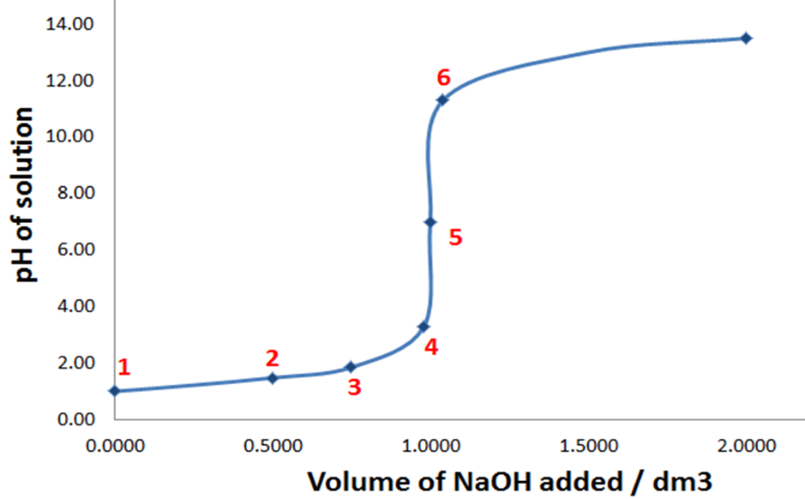
- Use pH curve to support answer:

Errors in titrations
- ▪ Systematic errors cause lower accuracy
- Use correct technique to eliminate
- Examples
- Faulty balance
- Some of substance/solution being left in original container
- Primary standard inflated due to having absorbed water
- ▪ Random errors cause lower precision
- Minimise by averaging several titre values - don't include outlier/anomaly
- Can never be eliminated
- Examples
- Uncertainty in measurements (last value after decimal place) - includes
scales
- Whether meniscus sits on line when using pipette

Back Titration
- Back titrations
  - When to use
    - One reactant is volatile (ammonia)
    - Acid/base is insoluble salt (calcium carbonate)
    - Reaction is too slow
    - Weak acid/base titration (no clear end point to approximate equivalence)
  - Method
    - React acid/base with a known amount of an excess reagent (standard solution that is a strong base/acid)
    - Excess reagent remaining is titrated with a standard solution that is a strong acid/base to determine the number of moles of the excess reagent remaining
    - Subtract this value from the initial number of moles of the excess reagent to give the number of moles that reacted with the unknown acid/base
    - Thus, can work out the number of moles and concentration of unknown acid/base in original substance

